User Access Management Process

Security Classification: Protected

Document Ref. ISMS15002
Version: 1.0
Draft 1

Document Author: Cybersecurity Unit
Document Owner: NCS/ TMP

Revision History

Version | Date | Change Number | Summary of Changes

Document Review

Date of Next Scheduled Review

Distribution

Name | Title

Approval

Name | Position | Signature | Date

Contents

1 Introduction 5
1.1 Risks Addressed 5
1.2 Scope 5
1.3 Related Documents 5
1.4 Purpose 5
2 User Registration 6
2.1 Requesting Access 7
2.2 Access Approval or Rejection 7
2.3 User Account Creation 7
2.4 Allocation of Secret Authentication Information 8
2.5 User Access Rights Assignment 8
2.6 Informing the User 8
3 User Access Adjustment 9
3.1 User Access Adjustment Request 9
3.2 Access Approval or Rejection 10
3.3 Adjust Access Rights 10
3.4 Informing the User 10
4 User Deregistration 11
4.1 Deregistration Request 11
4.2 Assess Urgency 11
4.3 Disable User Account 12
4.4 Retrieve Authentication Token 12
5 Management of Privileged Access Rights 13
6 Access Reviews 14
6.1 Define Scope 14
6.2 Inform System Owner(s) 14
6.3 Create User Access Report 15
6.4 Send Report to System Owner(s) 15
6.5 Review Access and Identify Changes 15
6.6 Implement Changes 16

Introduction

Risks Addressed

This document describes a control that was identified in ISMS06004 Information Security Risk Treatment Plan to address the following risks:

Reference | Description of Risk

Scope

This control applies to all systems, people and processes that constitute the organisation’s information systems, including board members, directors, employees, suppliers and other third parties who have access to Project Management Office (PMO)systems.

Related Documents

The following policies and procedures are relevant to this document:

- ISMS15001 Access Control Policy
- ISMS12002 Mobile Computing Policy
- ISMS12003 Teleworking Policy
- ISMS15003 Procedure for Remote Supplier Access to Systems
- ISMS15004 Procedure for the Reset of User Passwords

Purpose

The creation of new user accounts and the on-going management of system access are fundamental to the provision of effective information security. This process describes how user accounts and access rights should be requested, approved, created, amended, reviewed, and removed in a secure way which complies with Project Management Office (PMO)policies.

User Registration

This process must be followed for all user creations, including those of users within the Cybersecurity unit. The PMO maintains and supports a wide variety of IT systems and the level of access required by individuals to these systems in order to perform their job role will vary widely across the organisation. Although the specifics of how users are created will also vary across systems, the following basic process should always be followed.

The process of user registration is shown in the diagram below.

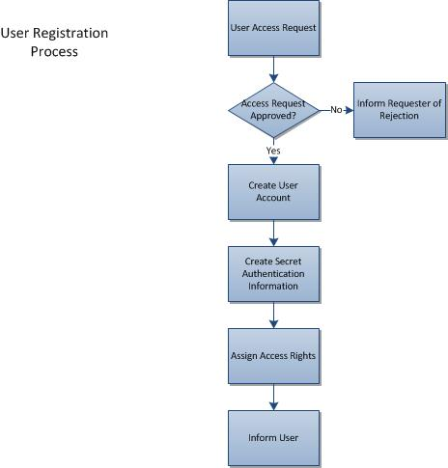

This process is described in more detail in the remainder of this section, including provision for the segregation of duties in line with PMO information security policy.

Requesting Access

Access to IT systems should be requested via the cybersecurity unit or user. Where online or electronic forms are available for specific systems these should be used. In addition to system-specific details, the following should always be given:

- Name
- Role
- Department
- Contact Details
- Start date (and end date if applicable)

For each system to which access is requested, further information may be required such as:

- Name of an existing user whose access should be duplicated (if new user is performing the same or similar role)
- Modules required.

Where possible, requests for access should be pre-approved by the system owner or Officer in Charge before being submitted to the cybersecurity unit from the approver’s email address.
Where physical forms are used to request access to IT systems, the same information should be given. These forms should be securely stored and comply with all applicable PMO policy.

Access Approval or Rejection

All requests for access to a specific system must be approved by the Officer in Charge or system owner.

No user accounts should be created without the required approval having been given. If approval is refused, the cybersecurity unit will inform the submitter of the request, together with any reason given.

User Account Creation

Once an approved request with sufficient details has been received, the Project Management unit will manage the creation of the user account. This may be done by the Project Management unit (for physical access provisioning) or passed to the cybersecurity unit (for system access provisioning) to perform. User accounts should be created in line with the standards established and documented for that specific system. These will detail parameters such as account name format, initial program calls, assigned printers etc. Account creations will be logged via the Cybersecurity unit System as service requests and tracked through to closure. The name of the Cybersecurity unit analyst creating the user account must also be recorded.

Allocation of Secret Authentication Information

The Cybersecurity unit will set an initial password. This will be a strong password according to published guidelines. A random password generation tool may be used if available. The password will be set to expire upon first logon at which point the user will define a new password which is known only to them, and which meets the parameters defined for that system.

If additional authentication tools are to be used (such as an RSA Token) the appropriate procedure for the setup of these items should be followed.

User Access Rights Assignment

Once the user account has been created, the request should be assigned to a different member of the Cybersecurity unit team to assign the access rights to the account. Under no circumstances should the account be created, and access rights assigned by the same person. For most systems, this will be achieved by placing the user account in a specific group or role that is specified on the approved request.

Informing the User

Upon successful completion of account setup, the Cybersecurity unit will inform the user of the account name via email along with instructions regarding how to set a strong password when changing the initial one set by the IT Service Desk. The initial password should be communicated by telephone directly to the user after verifying the user’s identity. If the user is not available, a message should be left for them to contact the IT service desk. The password should not be left as a message.

If an authentication token is also required, this will be sent to the user by internal or external post. For external mail, a recorded delivery service should be used. Correct receipt of the token should be confirmed with the user by the Cybersecurity unit before communicating the initial password.

The service request will then be closed on the IT Service Management System.

User Access Adjustment

From time to time there is a need to amend user access rights, often as a result of role changes. This adjustment must be carried out in a secure manner to ensure that the principles set out in the Access Control Policy are maintained.

The process for user access adjustment is shown below.

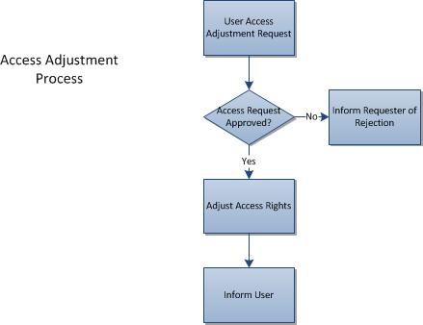

User Access Adjustment Request

Requests for adjustments to user access to IT systems should be sent to the Project Management unit and cybersecurity unit. Where online or electronic forms are available for specific systems these should be used. In addition to system-specific details, the following should always be given:

- Name
- Role
- Department
- Contact Details
- Name of Officer in Charge
- Date adjustment required from

If any of the above items of information are changing (e.g. a move of role or department) then both old and new details should be given).

For each system to which access is requested to be amended, further information may be required such as:

- Name of an existing user whose access should be duplicated (if amended user will be performing the same or similar role)
- Modules required

Where possible, requests for adjustments to access rights should be pre-approved by the system owner or Officer in charge before being submitted to the Cybersecurity unit from the approver’s email address.

Access Approval or Rejection

All requests for adjustments to access rights to a specific system must be approved by the system owner. This will normally be a manager within the organisation with specific responsibility for the security and use of that system.

No access rights should be amended without the required approval having been given. In the event that approval is refused, the Cybersecurity unit will inform the submitter of the request, together with any reason given.

Adjust Access Rights

Once the request has been approved, the request should be allocated to a member of the Cybersecurity unit team to assign the amended access rights to the account. For most systems, this will be achieved by placing the user account in a different group or role as specified on the approved request.

Informing the User

Upon successful completion of the adjustment request the Cybersecurity unit will inform the user via email.

If an authentication token is also required because of the adjusted access rights, this will be sent to the user by email.

User Deregistration

When an employee or contractor leaves the Project, it is vital that access controls are updated promptly to avoid a situation where an unauthorised person retains access to our systems.

This will be achieved using the process below.

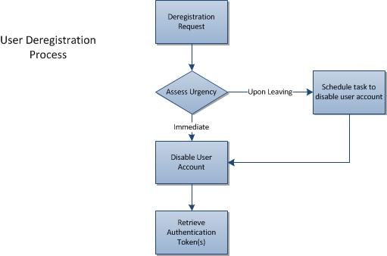

Deregistration Request

It is the responsibility of users and their managers to inform the Cybersecurity unit in a timely manner when employees leave the Project and so no longer need access to IT systems. As much advance notice as possible should be given. In those circumstances where an employee has been involuntarily terminated at short notice the Cybersecurity unit must be informed by telephone immediately.

Assess Urgency

The Cybersecurity unit will assess the urgency of the deregistration request based on the information provided and will decide whether to disable the user account straight away or to wait until the user leaves the organisation. In general, for unfriendly terminations deregistration will be completed immediately whereas for voluntary resignations it will be done on the day the person leaves.

Disable User Account

For most systems, the Cybersecurity unit will take the initial step of disabling the user account rather than deleting it. This will prevent access by the user but will retain all the information associated with the account and its data.

Later and with the system owner’s permission, the account may be deleted once any outstanding issues have been resolved.

All user accounts associated with the user in question should be disabled even if Single Sign On (SSO) is in place. This is necessary to prevent the account being used by someone who still has access to the network in future. Accounts should be disabled in order of importance.

Retrieve Authentication Token

If the deregistered user has an authentication token this should be retrieved as part of the termination process and returned to the IT service desk.

Management of Privileged Access Rights

Privileged access rights are those that involve a higher level of system access than a typical user. This includes “root” or “domain administrator” access and various types of supervisory access within application systems and databases.

The process for managing privileged access rights is basically the same as for other types of users but the approval and review aspects should be treated much more rigorously. The number of people with such rights should be carefully controlled and rights should be removed as soon as they are no longer required. The following factors should be considered by the system owner as part of the approval criteria for such requests:

- Why does the user need privileged access rights?
- Is there an alternative way to achieve the desired end result without granting privileged access rights?
- Does the user have the necessary training and expertise to avoid mistakes when using the privileged access rights?
- How long are the rights needed for?
- Is a documented agreement such as a Non-Disclosure Agreement required (e.g. for third parties)?

A user who requires privileged access rights such as domain admin should request that a separate user account be created with these rights. Under no circumstances should the password for the default admin user account be issued. If the need for access is temporary, then an expiry date should be set on the user account when it is created.

When creating such accounts it should be emphasised to the user that they are only for use when a higher level of permissions is needed and their normal, lower access level account should be used most of the time.

The need for accounts to hold privileged access rights will be reviewed according to the standard review process but may be performed on a more frequent basis depending on the sensitivity of the system(s) involved.

Access Reviews

To ensure that access to IT systems is only available to authorised personnel, the project management unit or cybersecurity will carry out a user access review every 6 months.

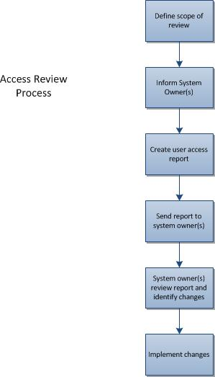

Define Scope

The scope of the review should be defined in terms of the systems and networks that will be covered.

Inform System Owner(s)

The owners of the systems and networks to be reviewed should be informed of the intention to carry out a review so that adequate time can be allocated to complete it within the target timescale.

Create User Access Report

The project management or cybersecurity unit will create a listing all of the authorised users of each system together with their current level of access. This should as a minimum state the following information:

- Name of system
- User name
- User role title
- User department
- User account name
- Date of user account creation
- User role(s) assigned
- Additional access rights assigned
- Are privileged access rights assigned to this account

Where appropriate, supporting information such as the specific permissions associated with each role defined in the system should also be provided.

Send Report to System Owner(s)

The report should be produced in electronic form (either spreadsheet or document) and securely emailed to the system owner. In some circumstances it may be appropriate to encrypt the file containing the report e.g. if it is to be sent to a remote office via the Internet.

Review Access and Identify Changes

The list will be reviewed by the system owner and any accounts that should not be maintained will be identified. If an account is found to have been accessed after an employee has left the Project, a security incident will be raised and investigated in accordance with documented procedures.

System owners will look to identify:

- People who should not have access (e.g. leavers)
- User accounts with more access than required by the role
- User accounts with incorrect role allocations
- User accounts that do not provide adequate identification e.g. generic or shared accounts.
- Any other issues that do not comply with the organisation’s access control policy.
Information
A list of issues identified should be compiled by the system owner and sent to the Officer in Charge. Any issues that appear to be urgent should be flagged as such without delay so that prompt action may be taken.

Implement Changes

Actions identified from the review should be prioritised and carried out according to their urgency. Non urgent issues may be added to the continual improvement plan as part of a wider programme of improvement. A record should be kept of all actions taken.

